**DEEP LEARNING**

## LAB ASSIGNMNET – 2

**NAME: HARIKA ADIVANNE**

**CLASS ID: 02**

**INTRODUCTION:**

In this assignment the main focus to implement text classification with CNN model and plotting the graph in tensor board to observe the results of changed parameters.

**Objective:**

The key objective here is to implement text classification with CNN model and plotting the graph in tensor board to observe the results of changed parameters and analyze the accuracy and loss based on the iterations.

**METHODS:**

Here I have implement CNN model by considering the data with different classes. Firstly created a class textcnn and declared placeholders for input, output and drop out so that it can be tracked for 12 regularization loss. Created convolutional and max pool layer for an each filter size, in this I applied non-linearity and combined all pool features ad finalized all the predictions to calculate loss accuracy for taken dataset.

For the training data I declared all the parameters such as model, training and misc parameters and loaded the data to build vocabulary and after shuffling data is splitted into training and testing, plotted summaries by declaring all the variables for accuracy and loss.

# WORKFLOW

* Installed required packages
* Applied convolution and max pooling
* Initialized variables
* Divided into training and testing
* Used parameters for prediction
* Calculated loss
* Calculated accuracy

**DATASETS:**

Iris data set is used to implement the logistic regression model. This dataset has three kinds of colors for petal and sepal length to store in n dimensional array.

**PARAMETERS:**

Number of iterations = 150

Optimizer rate=0.005

**EVALUATION:**

**Source code:**

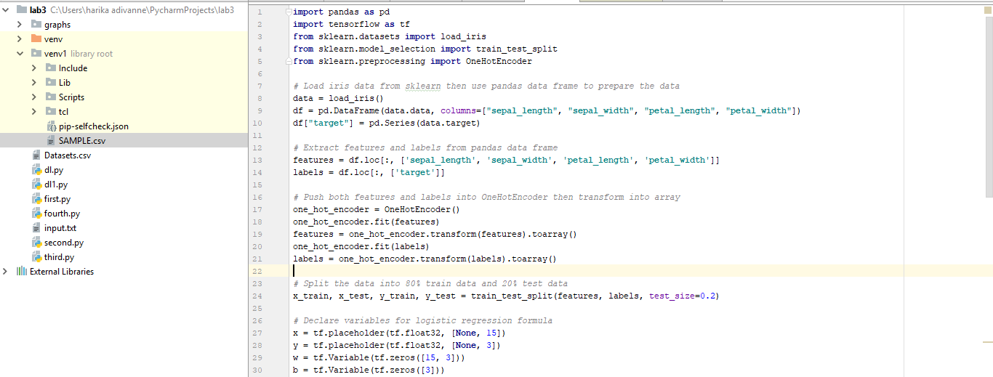

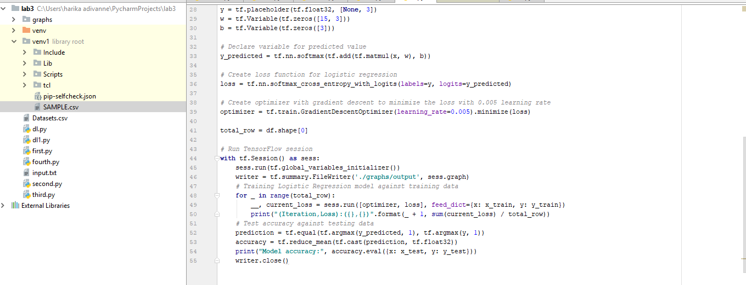Here I have used packages like pandas and sklearn to fit the data into data frame and divided the data into training and testing and used one hot encoding to make computation easier. To implement logistic regression here I have used iris data and calculated accuracy.

**OUTPUT:**

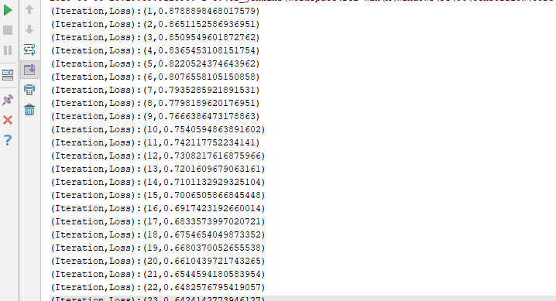

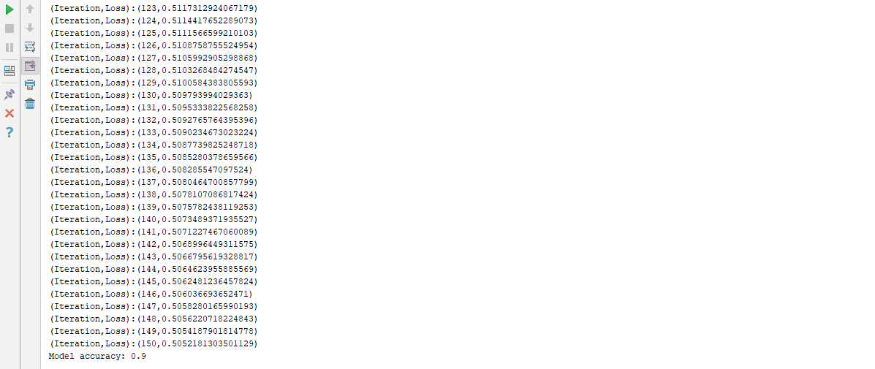

**CONCLUSION:**

The accuracy results in 0.9 for the parameter of 0.003 if the parameter differs, accuracy differs and for the less parameter value accuracy increases suppose for 0.0001 the accuracy is 0.9666. In this I have used 150 iterations.